Name: Zainab Azeem

Roll no: 21P-8025

Program: BCS

1. Write a function that takes one number as an argument and return their factorial.

**CODE**

def function():

num=int(input("enter number:"))

i=1

factorial=1

while i<=num:

factorial=factorial*i

i=i+1

print("factorial is",factorial)

function()

Output

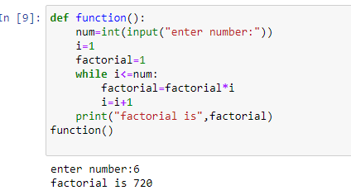

Write a Python program to create the multiplication table (from 1 to

10) Of a number.

**CODE**

num=int(input("enter number"))

i=1

while i<=10:

a=num*i

print(num, 'x', i, '=', num*i)

i+=1

Output

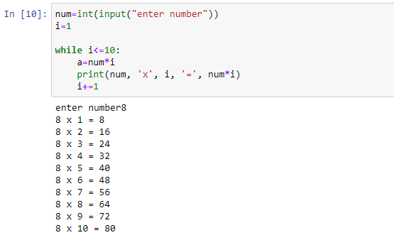

3. Modify a calculator you made in the last lab. This time your function ask user to

enter the number and the operation you want to perform (+,-,*,/) after the

operation is performed your program should ask the user whether you want to

continue (Y/N)? your program will exit only when user enter “N”

CODE

def operations():

question="y"

while question=="y":

number1=int(input("enter number1:"))

number2=int(input("enter number2:"))

print("for addition, press 1")

print("for subtraction, press 2")

print("for multiplication, press 3")

print("for division, press 4")

operation=int(input('enter operation:'))

if operation==1:

print("addition",number1+number2)

elif operation==2:

print("subtraction",number1-number2)

elif operation==3:

print("multiplication",number1*number2)

elif operation==4:

print("division",number1//number2)

question=input("do you want to continue? y/n")

operations()

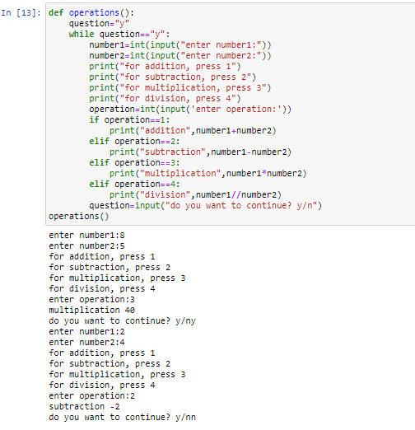

4. Write a function that takes two numbers as an argument and return their LCM.

CODE

def lcm(x,y):

if x>y:

a=x

else:

a=y

while True:

if a%x==0 and a%y==0:

print("the lcm is",a)

break

else:

a+=a

x=int(input("enter no:"))

y=int(input("enter no:"))

lcm(x,y)

Output

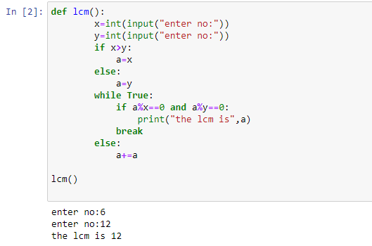

5. Write a function that takes two numbers as an argument and return their HCF

(Highest Common Factor) /GCD (Greatest Common Divisor).

**CODE**

x=int(input("enter no"))

y=int(input("enter no"))

def hcf(x,y):

if x < y:

a= x

else:

a = y

for i in range(1, a+1):

if((x % i == 0) and (y % i == 0)):

hcf = i

return hcf

print("The hcf is", hcf(x,y))

Output

